**FLIPKART AGILE**

Flipkart’s breakdown into **Epics**, **Features**, **User Stories**, and **Tasks**:

**Epic 1: Account**

1. **Feature: Login & Signup**  
   • **User Story:** Sign in or sign up.  
   • **Tasks:**  
   (i) UI – login/signup form  
   (ii) API – Handle authentication  
   (iii) DB – Store and retrieve user credentials
2. **Feature: Profile**  
   • **User Story:** Create and edit profile.  
   • **Tasks:**  
   (i) UI – Design profile edit screen  
   (ii) API – Update profile details  
   (iii) DB – Update user info

**Epic 2: Product Browsing**

1. **Feature: Search**  
   • **User Story:** Search for products.  
   • **Tasks:**  
   (i) UI – Search bar and display results  
   (ii) API – Create product search endpoint  
   (iii) DB – Fetch matching products
2. **Feature: Filters**  
   • **User Story:** Filter products.  
   • **Tasks:**  
   (i) UI – Add filter options (price, brand, rating)  
   (ii) API – Handle filter queries  
   (iii) DB – Support filtering fields

**Epic 3: Product Details**

1. **Feature: Product Description & Specs**  
   **User Story:** View Description and specifications.  
   • **Tasks:**  
   (i) UI – Add description and spec sections  
   (ii) API – Fetch detailed specs from catalog  
   (iii) DB – Store specs in structured format
2. **Feature: Bought Together & Recently Viewed**

• **User Story:** Related products.  
• **Tasks:**

(i) UI – Display "Frequently Bought Together" carousel

(ii) API – Fetch related product suggestions  
(iii) DB – Store product pairing data & browsing history per user

(iv) UI – Add "Recently Viewed" section

1. **Feature: Ratings & Reviews**  
   • **User Story:** Reviews.  
   • **Tasks:**  
   (i) UI – Display Reviews  
   (ii) API – Add and retrieve reviews  
   (iii) DB – Store and fetch reviews

**Epic 4: Cart & Payment**

1. **Feature: Cart**  
   • **User Story:** Add or remove items from the cart.  
   • **Tasks:**  
   (i) UI – Display cart list   
   (ii) API – Add/ Remove / update cart items  
   (iii) DB – Store Cart data
2. **Feature: Payment**

• **User Story:** Manage addresses.  
• **Tasks:**  
(i) UI – Add Address Input  
(ii) API – Add or remove address  
(iii) DB – Store saved address

• **User Story:** Select payment mode.  
• **Tasks:**  
(i) UI – Add UPI/Net Banking/Cash on Delivery options  
(ii) API – Validate payment success and failure callbacks  
(iii) DB – Store saved cards

• **User Story:** Check EMI options   
• **Tasks:**  
(i) UI – Display EMI options on product and checkout pages  
(ii) API – Fetch EMI and credit plan data  
(iii) DB – Store EMI and financial plan info

• **User Story:** Place Order.  
• **Tasks:**  
(i) UI – View order summary  
(ii) Backend – Calculate order total and summary  
(iii) API – Confirm and place order  
(iv) DB – Store order details

**Epic 5: Order Management**

1. **Feature: Order History**  
   • **User Story:** View past orders.  
   • **Tasks:**  
   (i) UI – Show list of previous orders  
   (ii) API – Retrieve user order history  
   (iii) DB – Fetch stored order records
2. **Feature: Track Orders**  
   • **User Story:** Track order delivery.  
   • **Tasks:**  
   (i) UI – Display order tracking page  
   (ii) API – Track order status  
   (iii) DB – Store delivery status updates

**Epic 6: Offers & Rewards**

1. **Feature: Coupons**  
   • **User Story:** Apply discount codes.  
   • **Tasks:**  
   (i) UI – Input field for promo code  
   (ii) API – Validate and apply discounts  
   (iii) DB – Fetch available coupons
2. **Feature: Rewards**  
   • **User Story:** Use Flipkart Plus rewards.  
   • **Tasks:**  
   (i) UI – Display and apply reward points  
   (ii) API – Calculate and redeem rewards  
   (iii) DB – Store user reward balance

**Epic 7: Wishlist & Save for Later**

* 1. **Feature: Wishlist**

• **User Story:** Use Flipkart Plus rewards.  
• **Tasks:**

(i) UI – Add to wishlist button

(ii) API – Save/remove item in wishlist

(iii) DB – Store wishlist by user

* 1. **Feature: Save for Later**

• **User Story:** Use Flipkart Plus rewards.  
• **Tasks:**

(i) UI – "Save for Later" option in cart

(ii) API – Move items from cart to saved list

(iii) DB – Maintain separate table for saved items

**Epic 8: Customer Service**

1. **Feature: Help Center**  
   • **User Story:** Get help and support.  
   • **Tasks:**  
   (i) UI – Show FAQs and support chatbot  
   (ii) API – Submit help queries  
   (iii) DB – Log support requests
2. **Feature: Returns & Refunds**  
   • **User Story:** Return a product.  
   • **Tasks:**  
   (i) UI – Add return button and show return status  
   (ii) API – Request and track refund  
   (iii) DB – Update order and refund
3. **Feature: Complaint Escalation**:

• **User Story:** Escalate unresolved issues.  
• **Tasks:**  
(i) UI – Escalation request button

(ii) API – Escalate to higher support tier

(iii) DB – Track complaint status and escalation flag

**EPIC:**

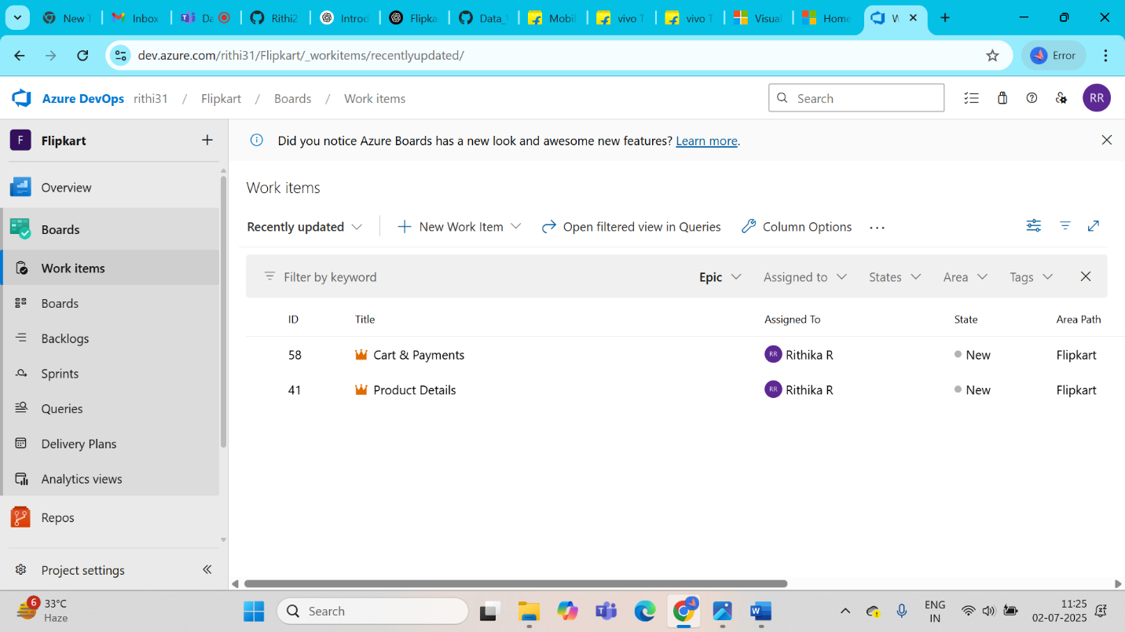

**FEATURES:**

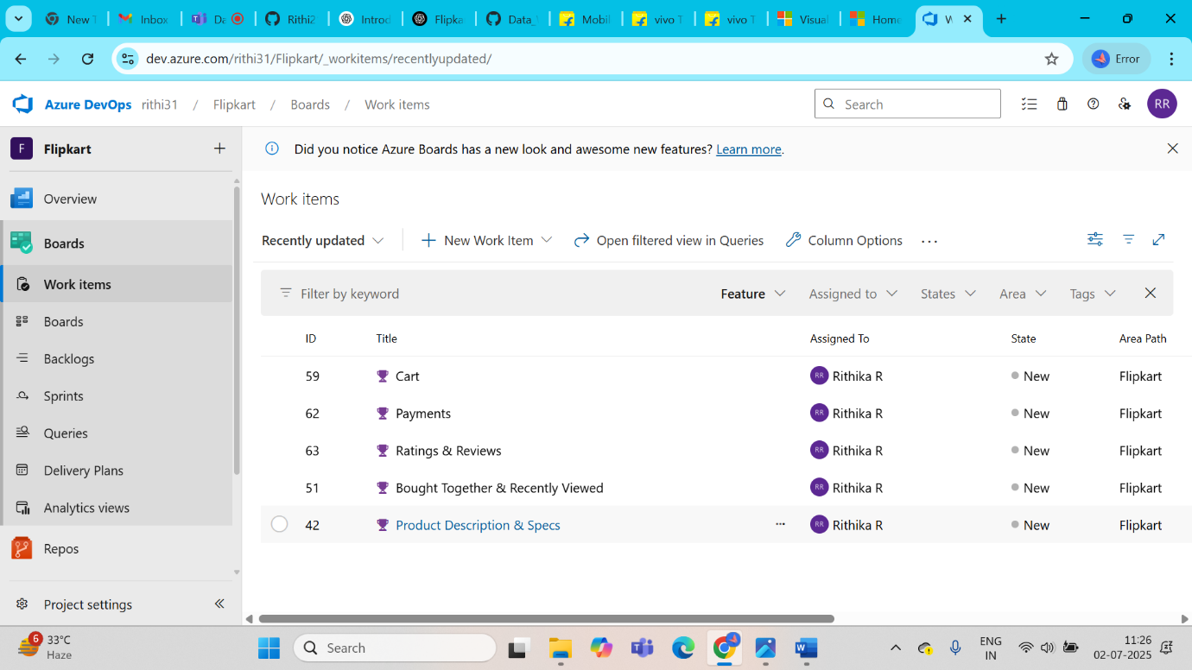

**USER STORY:**

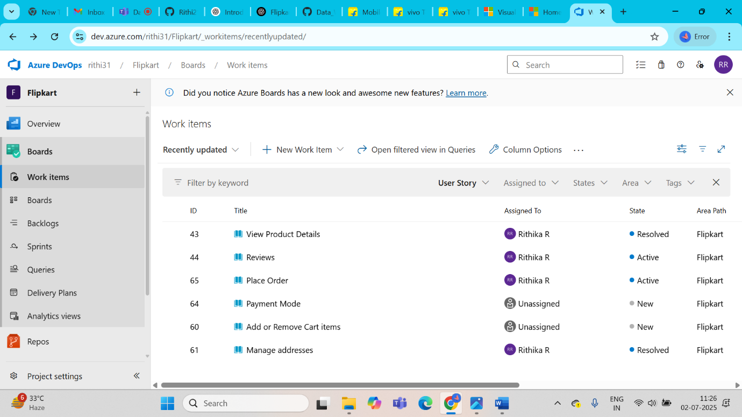

**TASKS:**

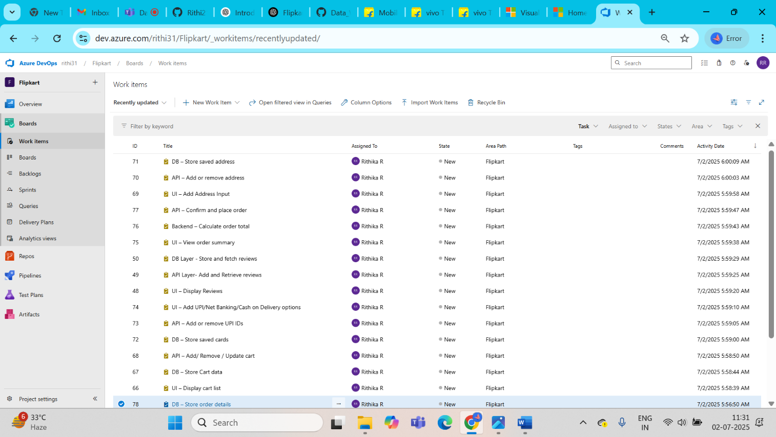

**BOARDS:**

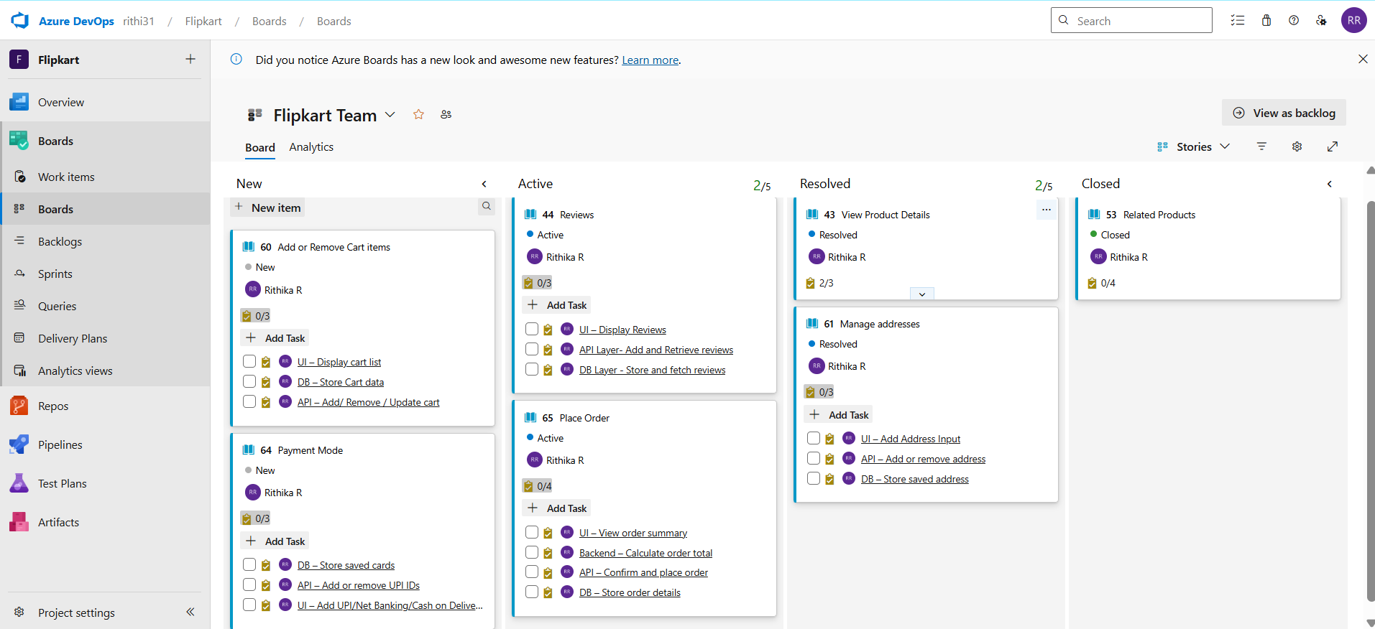

**BACKLOGS:**

